Breadboard prototype
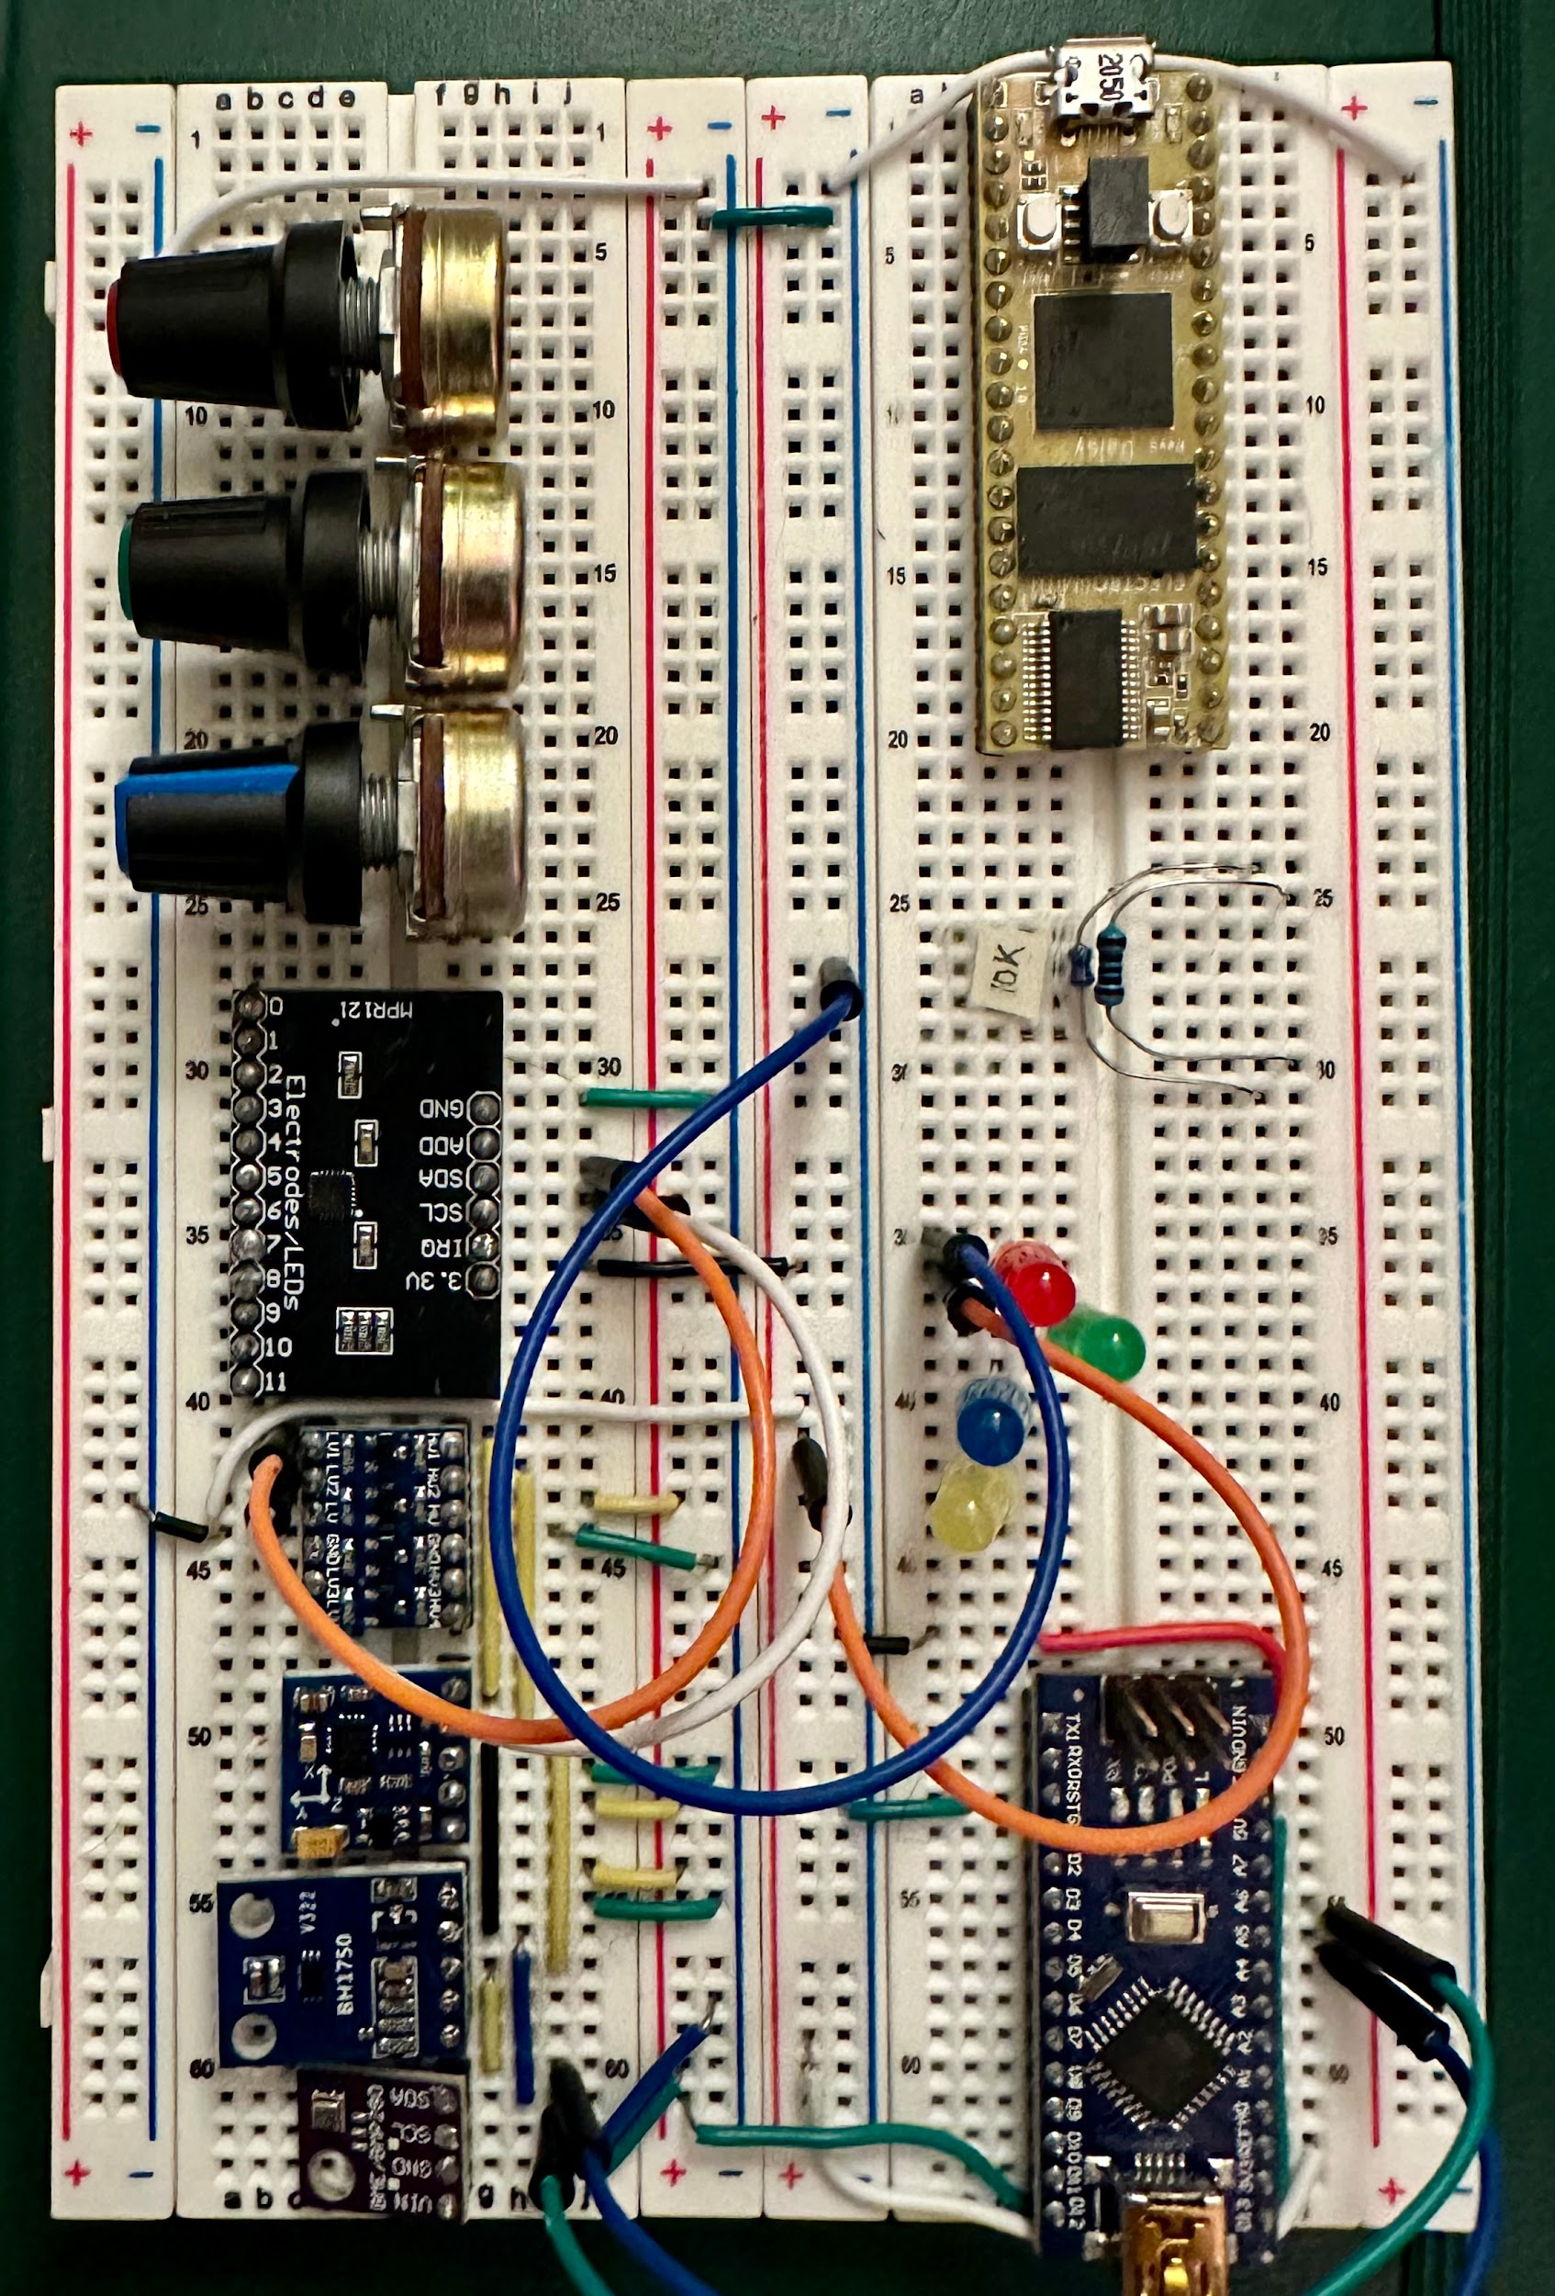

Sensors

Sensor ID | Other names | Sensor Name | Voltage | I²C
BH1750 |  | Light | 3-5 | 0x23
MPR121 |  | Cap Touch | 3.3
BME280 | BMP280 | Temp Press Humid | 5 | 0x76
HW246 | QMC5883L  GY121 | Magnetic Field | 3-5 | 0x0D

Tested all the sensors using code generated via chatGPT and all seemed to work as desired. The capacitive touch sensor was probably the most tricky. 1) because it requires transferring the logic from 3.3V to 5V (If i wanted all the sensors to remain on the same line). And 2) it was a bit finicky to calibrate.

Important Arduino code

3 data streams
The following code is intended to output temperature, lux, and MagX

#include <Wire.h>
#include <Adafruit_BME280.h>
#include <Adafruit_Sensor.h>
#include <BH1750.h>
#include <QMC5883LCompass.h>

// Sensor objects
Adafruit_BME280 bme; // BME280 environmental sensor
BH1750 lightMeter; // BH1750 light sensor
QMC5883LCompass mag; // QMC5883L magnetometer

void setup() {
Serial.begin(9600);
Wire.begin();

// Initialize BME280
if (!bme.begin(0x76)) {
Serial.println("BME280 not found!");
}

// Initialize BH1750
if (!lightMeter.begin(BH1750::CONTINUOUS_HIGH_RES_MODE)) {
Serial.println("BH1750 not found!");
}

// Initialize QMC5883L
mag.init(); // NOTE: no return value
}

void loop() {
// Read temperature
float tempC = bme.readTemperature();

// Read light level
float lux = lightMeter.readLightLevel();

// Read magnetometer
mag.read();
int magX = mag.getX(); // choose X-axis only

// Print values in a clean PD-friendly packet
Serial.print("TEMP "); Serial.print(tempC);
Serial.print(" LIGHT "); Serial.print(lux);
Serial.print(" MAGX "); Serial.println(magX);

delay(50);
}

Arduino Libraries:
- QMC5883LCompass

Sensor Specifications:

BME280
Specification:
Model: BME280
Interface: I2C and SPI
Supply Voltage: 5V
Operating range: -40˚C to +85˚C
Rel. humidity: 300-1100 hPa
Humidity Range: 0 - 100 %

Features:
1. Digital interface I2C (up to 3.4 MHz) and SPI (3 and 4 wire, up to 10 MHz)
2. Supply voltage VDD main supply voltage range: 1.71 V to 3.6 V, VDDIO interface voltage range: 1.2 V to 3.6 V
3. Current consumption:
1.8 uA @ 1 Hz humidity and temperature
2.8 uA @ 1 Hz pressure and temperature
3.6 uA @ 1 Hz humidity, pressure and temperature
0.1 uA in sleep mode

Package Inlcuding:
4 X GY-BME280-5V Sensor
4 X 4P Straight Pin Header
Pure data patch screenshots

Simple com7 serial read patch

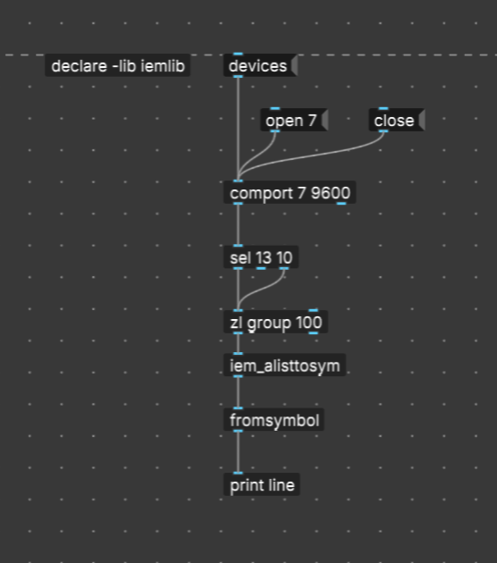

Puredata externals
- eimlib
- comport

